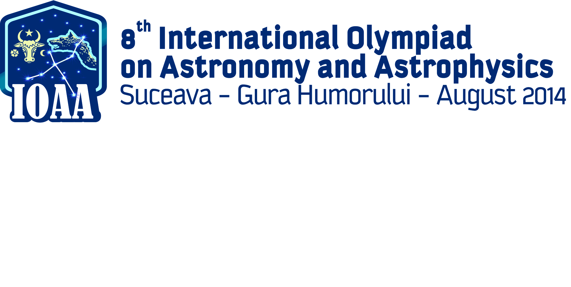

**Content**

Indications 2

Problem 1. Lagrange Points 3

Problem 2. Sun gravitational catastrophe! 3

Problem 3. Cosmic radiation 3

Problem 4. Mass function of a visual binary stellar system 4

Problem 5. The Astronaut saved by … ice from a can! 4

Problem 6. The life –time of a star from the main sequence 5

Problem 7. The effective temperature on the surface of a star 5

Problem 8. Gradient temperatures 6

Problem 9. Pressure of light 6

Problem 10. The density of the star 7

Problem 11. Space – ship orbiting the Sun 7

Problem 12. The Vega star in the mirror 7

Problem 13. Stars with Romanian names 8

Problem 14. Apparent magnitude of the Moon 8

Problem 15. Absolute magnitude of a cepheide 8

# Indications

1. The problems were elaborated concerning two aspects:
   1. To cover merely all the subjects from the syllabus;
   2. The average time for solving the items is about 15 minutes per a short problem;
2. In your folder you will find out the following:
   1. Answer sheets
   2. Draft sheets
   3. The envelope with the subjects in English and the translated version of them in your mother tongue;
3. The solutions of the problems will be written down only on the answer sheets you receive on your desk. **PLEASE WRITE ONLY ON THE PRINTED SIDE OF THE PAPER SHEET. DON’T USE THE REVERSE SIDE**. The evaluator will not take into account what is written on the reverse of the answer sheet.
4. The draft sheets is for your own use to try calculation, write some numbers etc. BEWARE: These papers are not taken into account in evaluation, at the end of the test they will be collected separately . Everything you consider as part of the solutions have to be written on the answer sheets.
5. Each problem have to be started on a new distinct answer sheet.
6. On each answer sheet please fill in the designated boxes as follows:
   1. In PROBLEM NO. box write down only the number of the problem: i.e. 1 – 15 for short problems, 16 – 19 for long problems. Each sheet containing the solutions of a certain problem, should have in the box the number of the problem;
   2. In Student ID – fill in your ID you will find on your envelope, consisted of 3 leters and 2 digits.
   3. In page no. box you will fill in the number of page, starting from 1. We advise you to fill this boxes after you finish the test
7. We don’t understand your language, but the mathematic language is universal, so use as more relationships as you think that your solution will be better understand by the evaluator. If you want to explain in words we kindly ask you to use short English propositions.
8. Use the pen you find out on the desk. It is advisable to use a pencil for the sketches.
9. At the end of the test:
   1. Don’t forget to put in order your papers;
   2. Put the answer sheets in the folder 1. Please verify that all the pages contain your ID, correct numbering of the problems and all pages are in the right order and numbered. This is an advantage of ease of understanding your solutions.
   3. Verify with the assistant the correct number of answer sheets used fill in this number on the cover of the folder and sign.
   4. Put the draft papers in the designated folder, Put the test papers back in the envelope.
   5. Go to swim

**GOOD LUCK !**

# Lagrange Points

The *Lagrange* points are the five positions in an orbital configuration, where a small object is stationary relative to two big bodies, only gravitationally interacting with them. For example, an artificial satellite relative to Earth and Moon, or relative to Earth and Sun. In the **Figure 1** are sketched two possible orbits of Earth relative to Sun and of a small satellite relative to the Sun. Find out which of the two points and  could be the real Lagrange point relative to the system Earth – Sun, and calculate its position relative to Sun. You know the following data: the Earth - Sun distance and the Earth – Sun mass ratio 













**Fagure 1**

# Sun gravitational catastrophe!

In a gravitational catastrophe, the mass of the Sun mass decrease instantly to half of its actual value. If you consider that the actual Earth orbit is elliptical, its orbital period is  and the eccentricity of the Earth orbit is 

Find the period of the Earth`s orbital motion, after the gravitational catastrophe, if it occurs on: a) 3rd of July b) 3rd of January.

# Cosmic radiation

During studies concerning cosmic radiation, a neutral unstable particle – the meson was identified. The rest-mass of meson is much larger than the rest-mass of the electron. The studies reveal that during its flight, the meson disintegrates into 2 photons.

Find an expression forthe initial velocity of the meson, if after its disintegration, one of the photons has the maximum possible energy  and, consequently, the other photon has the minimum possible energy. You may use as known **c -** the speed of light.

# Mass function of a visual binary stellar system

For a visual binary stellar system consisted of the stars  and  the following relation represents the mass function of the system:



where  is the mass of star,  is the mass of star and *i*  is the angle between the plane of the stars’ orbits and a plane perpendicular on the direction of observation.

The recorded spectrum of radiations emitted by the star , during several months, reveals a sinusoidal variation of radiation wavelength, with the period T = 7 days and a shift factor 

1. Prove that the mass function of the system is:



Where:  is the maximum speed of star  relatively to the observer;  the gravitational constant , *i* is the angle between the plane of the orbits and the plane normal to the observation direction.

Assumptions: The orbits of the stars are circular,

1. Derive an expression for the mass function of the system. The following values are known:  

# The Astronaut saved by … ice from a can!

An astronaut, with mass get out of the space ship for a repairing mission. He has to repair a satellite standing still relatively to shuttle, at about  distance away from the shuttle. After he finished his job he realizes that the systems designated to assure his come-back to shuttle were broken. He also observed that he has air only for 3 minutes. He also noticed that he possessed a hermetically closed cylindrical can (base section) firmly attached to its glove, with of ice inside. The ice did not completely fill the can.

Determine if the astronaut is able to arrive safely to the shuttle, before his air reserve is empty. Briefly explain your calculations. Note that he cannot throw away anything of its equipment, or touch the satellite.

*You may use the following data:* / the temperature of the ice in the can, - the pressure of the saturated water vapors at the temperature; - the constant of perfect gas;  - the molar mass of the water.

# The life –time of a star from the main sequence

The plot of the function  for data collected from a large number of stars is represented in figure 3. The symbols represents: L and M the luminosity respectively the mass and of a star and  and respectively  the luminosity and the respectively the mass of the Sun.

























Figure 6

*Find an expression for the life- time* for each star in the Main Sequence from Hertzprung – Rossell diagram if the time spent by Sun in the same Main Sequence isConsider the following assumptions: for each star the percentage of its mass which changed into energy is , the percent of the mass of Sun which changes into energy is , the mass of each star is  and the luminosity of each star remains constant, during its entire life time.

# The effective temperature on the surface of a star

A star emits radiation with wavelength values in a narrow range , i.e. the wavelength have values between  and  and  . According to Planck's relationship (for an absolute black body), the following relation define, the energy emitted by star in the unit of time, through the unit of area of its surface, per length-unit of the wavelength range:



The spectral intensities of two radiations with wavelengths  and respectively , both in the range measured on Earth are  and, respectively 

1. Establish the equation which, in a general case, allows determining the effective temperature on the surface of the star using only spectral measurements.
2. Find out the approximate value of the effective temperature on the star surface if .
3. Find out the relation between wavelength  and  if  when 

You know: Planck’s constant; Boltzmann’s constant; speed of light in vacuum.

# Gradient temperatures

The spectra of two stars with different temperatures  and respectively  were compared. In the spectrum of each star, two very close spectral lines corresponding to the wavelength with values and respectively were found. For each line of this spectral lines, the difference between the corresponding visual apparent magnitudes of the stars are and . is the apparent magnitude of the star 1 for the wavelength ,  is the apparent magnitude of the star 1 for the wavelength  , is the apparent magnitude of the star 2 for the wavelength ,  is the apparent magnitude of the star 2 for the wavelength  .

*Determine* the temperature  of one of the two stars, if the temperature  of the other star is already known, by using the Plank expression of black body radiation:



where: Planck’s constant;  Boltzmann’s constant; speed of light in vacuum. You will consider that 

# Pressure of light

One particle of star dust is in static equilibrium at a certain distance from Sun. Assuming that the particle is spherical and its density is , calculate the diameter of the particle.

The following assumption may be useful for solving the problem:

The pressure of electromagnetic radiation is equal with the volume density of the electromagnetic radiations

# The density of the star

In a very simple model, a star is assumed to be a sphere of gas in a state of equilibrium in its on gravitational field. The stellar gas is consisted of plasma, i.e. hydrogen and helium atoms, completely ionized. Find an expression for the value of the mass of the star if you know: radius of the star; the temperature of the star; the relative proportion of hydrogen in the mass of the star; molar mass of the hydrogen; molar mass of the helium; universal gas constant; gravitation constant. You may use the formula of the pressure of radiation inside the star  where *a* is a known constant. The rotation of the star is negligible.

# Space – ship orbiting the Sun

A spherical space –ship orbits the Sun on a circular orbit, and spin around one of its axes. The temperature on the exterior surface of the ship is . Find out the apparent magnitude of the Sun and the angular diameter of the Sun as seen by the astronaut on board of the space – ship. The following values are known:,  - the effective temperature of the Sun; - the radius of the Sun;  - the Earth –Sun distance; - apparent magnitude of Sun measured from Earth;  - the radius of the space –ship.

# The Vega star in the mirror

Inside a photo camera a plane mirror is placed along the optical axis of the lens of the objective (as seen in figure 13). The length of the mirror is half of the focal distance of the lens of the objective. The photo camera is oriented as on the photographic plate situated in the focal plane of the photo camera are captured two images with different illuminations of the Vega star. Find out the difference between the apparent photographical magnitudes of the two images of the Vega stars.





VEGA

star

Photographical plate

Plane mirror

Lens objective









Figure 13

# Stars with Romanian names

Two Romanian astronomers Ovidiu Tercu and Alex Dumitriu from The Astronomical Observatory of the Museum Complex of Natural Sciences in Galati Romania, recently discovered – in September 2013- two variable stars. They used for that a telescope with the main mirror diameter of 40 cm and a SBIG STL-6303e CCD camera.

With the accord of the **AAVSO** (**A**merican **A**ssociation of **V**ariable **S**tars **O**bservers), the two stars have now Romanian names: Galati V1 and respectively Galati V2. The two stars are circumpolar, located in Cassiopeia and respectively in Andromeda constellation. The two stars are visible above the horizon, form the territory of Romania, all over the year. The galactic coordinates of the two stars are:  and .

Another star, discovered by the Romanian astronomer Nicolas Sanduleak, has also a Romanian name – Sanduleak -69° 202; it explodes as the supernova SN 1987. This star was localized in the Dorado constellation from the Large Magellan Cloud, by the coordinates:

 

Estimate the angular distance between the stars Galati V1 and Galati V2.

# Apparent magnitude of the Moon

You know that the absolute magnitude of the Moon is . Calculate the values of the apparent magnitudes of the Moon corresponding to the following Moon –phases : full-moon and the first quarter. You know: the Moon – Earth distance - , the Earth – Sun distance - , the Moon –Sun distance, 

# Absolute magnitude of a cepheide

The cepheides are cariable stars, whom luminosities and luminosities varies due to volume oscillations. The period of the oscilations of a cepheide star is:



where: the radius of the cepheide; the mass of the cepheid (constant during oscillation);



Demonstrate that the absolute magnitude of the cepheide  depend on the period of cepheide’s pulsation P according the following relation:



where k is constant; 